Giving Directions
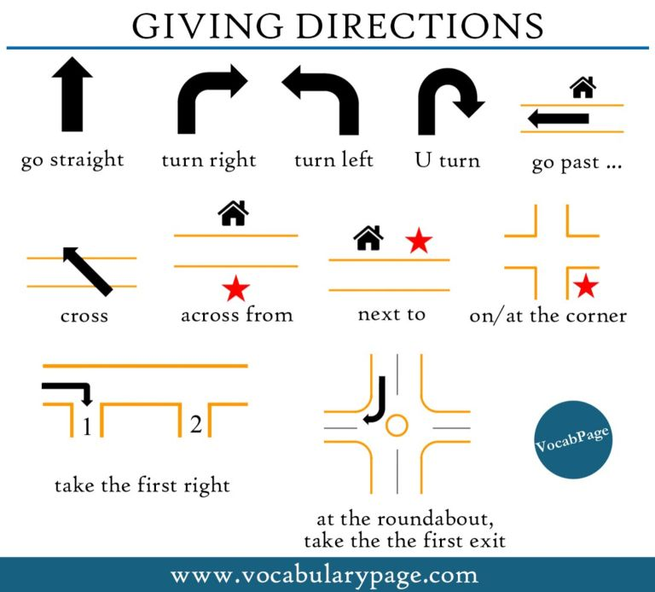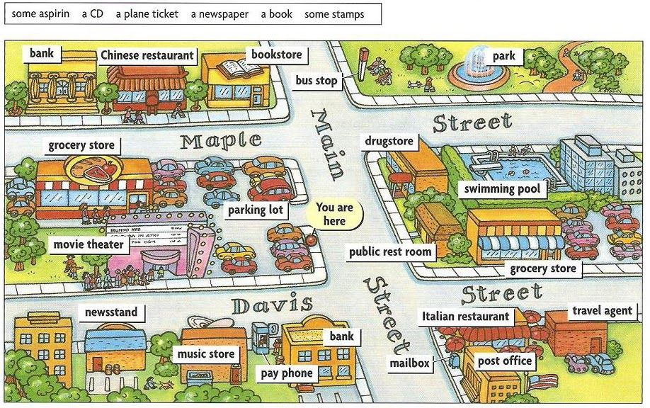
Prepositions of Time
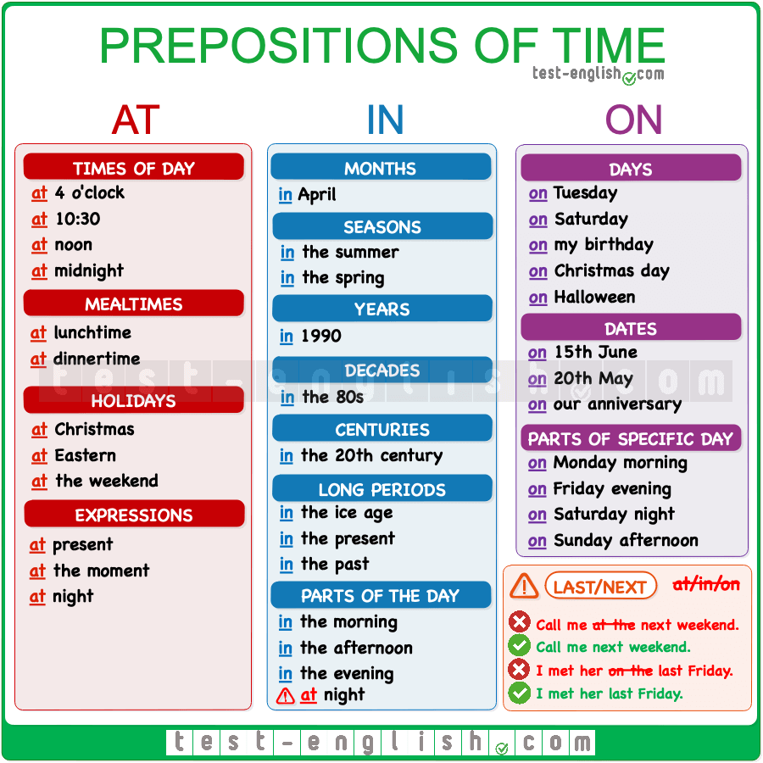

Daily Routine
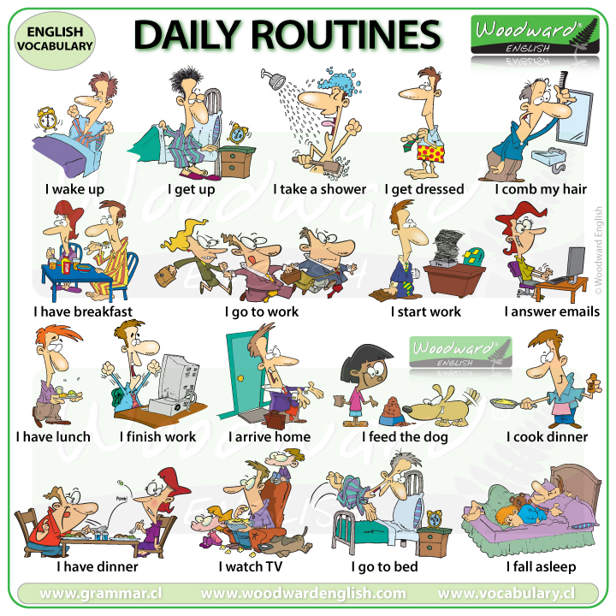
Activity: https://es.liveworksheets.com/worksheets/en/English_as_a_Second_Language_(ESL)/Daily_routines/One_day_in_my_life_vo1253533cz

Adverbial for Habits
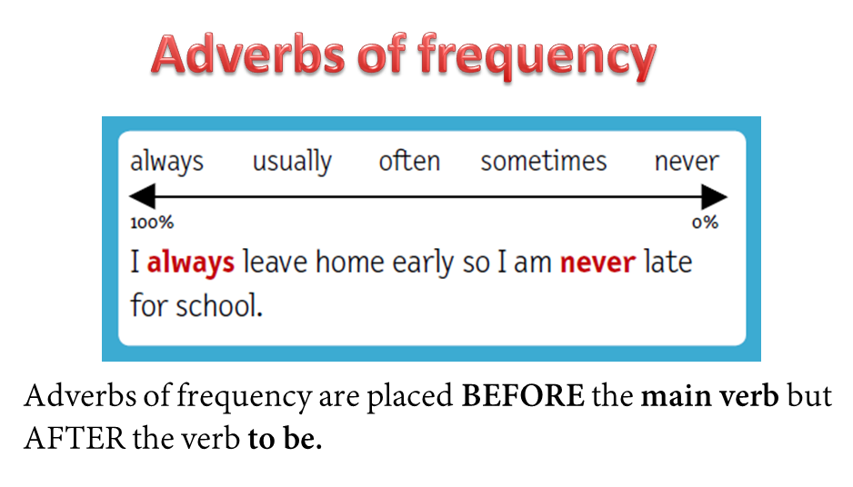
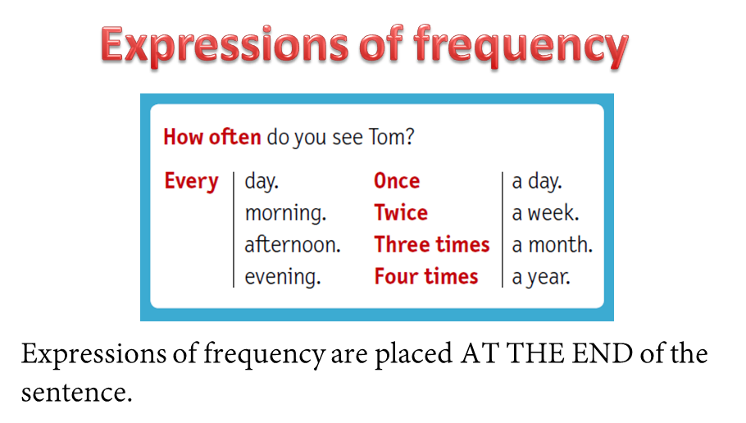
Activity: https://es.liveworksheets.com/worksheets/en/English_as_a_Second_Language_(ESL)/Adverbs_of_frequency/Frequency_adverbs_and_household_chores_in31583qp

Once in the wilde
De vez en cuando

